Comparison of Diagnostic Accuracy of Appendicitis Inflammatory Response Score and Alvarado Score in Diagnosis of Acute Appendicitis Taking Histopathology as Gold Standard

TAHIRA TARIQ¹, HINA REHMAN SIDDIQUI², IMRAN AHMED KHAN³, AYESHA TASNEEM⁴, SOBIA MAJEED⁵
¹MBBS, FCPS General Surgery Abbasi Shaheed Hospital Karachi, Pakistan
²MBBS, General Surgery Roscommon University Hospital, Ireland
³MBBS, MS General Surgery, Abbasi Shaheed Hospital Karachi, Pakistan
⁴MBBS, FCPS General Surgery, Abbasi Shaheed Hospital Karachi, Pakistan
⁵MBBS, FCPS General Surgery, Abbasi Shaheed Hospital Karachi, Pakistan
Correspondence to: Tahira Tariq, Email: tahiratariq@hotmail.com, Cell: +92 311 8956973

ABSTRACT:
Objective: To compare the diagnostic accuracy of appendicitis inflammatory response score and Alvarado score in diagnosis of acute appendicitis taking histopathology as gold standard.
Study Design: It is a Cross Sectional Study
Study setting and Duration: This study conducted at the Department of General Surgery, Abbasi Shaheed Hospital, Karachi from September 2018 To March 2019.
Methods: Alvarado and Appendicitis inflammatory response scores were used to evaluate all patients. For the Alvarado scoring system, a score of 7 or more was considered a high chance of acute appendicitis, while the AIR scoring system required a score of 9 or higher. The findings of the histopathology lab were compared to the test results. Both tests' results were analysed to determine their sensitivity, specificity, and diagnostic accuracy.
Results: For Alvarado score Sensitivity (80.1%), Specificity (92.3%) and accuracy was 81.7%. For AIR score Sensitivity (72.6%), Specificity (94.2%), and accuracy was 75.5%. There were 66.9% male and 33.1% female patients. Right iliac fossa pain was 76.8%, pain migration to right iliac fossa was 63.5%, anorexia was 90.9%.
Conclusion: Higher sensitivity and specificity of the Appendicitis inflammatory response score and the Alvarado score were found to outperform the histological findings in appendicitis.
Keywords: Appendicitis, Appendicitis Inflammatory Response Score, Diagnostic Accuracy, Acute Appendicitis, Histopathology, Alvarado Score,

INTRODUCTION
One of the most prevalent surgical emergencies is acute appendicitis (AA).¹ At 1.17 per 1000 people, this is the most common cause of acute abdominal discomfort with an incidence of 8.6 percent in males and 6.9 percent in females.² Clinician experience has a significant impact on the degree of clinical examination accuracy, which has been observed to range from 71% to 97%. The gold standard for diagnosing appendicitis, histology of the resected appendix, has been found to be negative in many individuals who have undergone appendectomy.^{4,5} Patients and health care workers alike suffer from the removal of a normal appendix. While improving decision-making speed and accuracy, an ideal scoring system would also eliminate the need for potentially damaging and costly imaging.² As a result of diagnostic assistance, the frequency of appendectomies performed on patients without appendicitis and the length of hospitalisation have been reduced.^{7,8} Helpful tools include diagnostic scoring systems (DSS), inflammatory markers, ultrasound (US) and laparoscopy and each with its own set of pros and cons. ⁷
Alvarado is a simple system for determining a winner. In order to accurately diagnose appendicitis, this scoring system employs eight characteristics totaling 10 points. The Alvarado scoring system has some limitations, including the omission of C-reactive protein (CRP) as a variable despite the fact that each measure is statistically and independently related to acute appendicitis.¹³ The Appendicitis Inflammatory Response Score, which incorporates CRP, was created to address these shortcomings.¹⁴ Clinical factors plus two straightforward laboratory tests, such as CRP and a full blood count, form the basis of the AIR scoring system, which can aid in a quicker and more accurate diagnosis.^{9,15-17}
A study investigated that 65% male and 35% female patients having mean age of patients was 28.9±12.89 years, on histopathology reported 89% cases as acute appendicitis. For AIR and Alvarado score (Score>4) sensitivity was 89.9% and 78.6% respectively while the specificity was 63.6% and 54.5% respectively. Alvarado's and AIR's sensitivity was 12.3% and 21.3%, respectively, but their specificity was 100% in both scoring categories.¹⁸ Patil S, et al. 2017 reported in his study that The histopathological investigation revealed that appendicitis had been present in 88 percent of the patients. This method's sensitivity and specificity were 78.11% and 100%, respectively, when used at the ideal cutoff point of 4, as opposed to 78.11% and 91.67% for the Alvarado system.⁹ For the clinical diagnosis of appendicitis, preliminary investigations have demonstrated that the appendix inflammatory response score is superior to and more accurate than the Alvarado scoring system.

MATERIAL AND METHODS
After taking permission from the IRB of the Hospital, this cross sectional study was conducted at department of general surgery of Abbasi Shaheed Hospital from September 2018 to March 2019.
Total 384 patients were included in the study's total sample size, based on the AIR scoring system's sensitivity of 78.41%¹⁹ and specificity of 91%¹⁹ at a cutoff point of >4, the prevalence of 88 percent¹⁹ positive appendicitis on the histopathological report, a confidence interval of 95%, and a precision of 8%. Non-probability consecutive sampling was used to obtain data via proforma following informed consent. Patients with a provisional clinical diagnosis of acute appendicitis, ranging in age from 20 to 60, gave their informed consent to participate in this study. The AIR and Alvarado scoring systems were used to evaluate each subject. A score of 7 or more on the Alvarado scoring system was considered a high chance of AA, while scores of 9 or more on the AIR scoring systems were considered high probability of AA accordingly. Systemic examinations were carried out on the patients. The surgical cases' histopathology findings were also gathered and correlated with the evaluation scores. The sensitivity, specificity, positive, and negative predictive values (NPVs) were derived from the scores. The histopathology reports' outcomes were tracked and documented. The SPSS statistical package version 21 was used to enter and evaluate the data. Age, Alvarado, and AIR score were used to compute the mean and standard deviation. Alvarado and AIR scoring systems (positive/negative) were used to calculate frequency and percentages for gender, signs, symptoms, laboratory findings, and the diagnosis of appendicitis. Stratification of age and gender was used to examine the influence of effect modifiers on outcome variables.

RESULT
Out of 384 patients, 66.9% (257) were male and 33.1% (127) were female. Mean age of patients was 26.48±6.11 years. Mean Alvarado score and AIR score was 6.46±2.96 and 6.05±3.43 respectively. Among 384 patients, 76.8% were found with RIF pain, 63.5% with pain migration to RIF, (90.9% with anorexia and 68.5% with nausea and vomiting. It was observed that 66.7% patients were found with RIF tenderness, 54.9% with guarding, 62.2% with rebound tenderness and 64.1% with rovsing sign. The results showed that 68.8% were found with elevated blood cell count and 66.1% with negative urine analysis. In our study, 70.3% patients were diagnosed positive by Alvarado score, 63.5% through AIR score and 86.5% through histopathology.
It was found that 266 true positives and 48 true negatives correctly diagnosed using Alvarado score diagnostic accuracy results. Sensitivity and specificity were 80.1 percent and 92.3 percent respectively while the PPV, NPV and accuracy were 81.7 percent and 42.1% respectively. Stratification was also applied to gender and age groupings. Based on the Alvarado and AIR scores, the sensitivity, specificity, predictive values, and diagnostic accuracy were calculated.

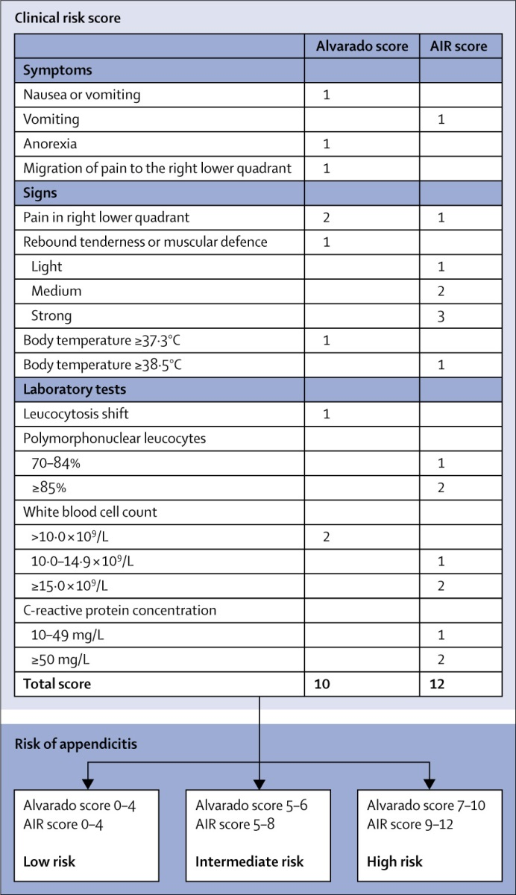
Figure 1: Clinical risk scoring for suspected acute appendicitis²⁵.
Table 1: Diagnostic Accuracy Of Alvarado Score For Appendicitis Diagnosis Taking Histopathology As Gold Standard (N=384)
Parameters | Alvarado score diagnosis |  |  | P - value
Histopathology | Positive | Negative | Total | 0.000
Positive | 266 (80.1) | 66 (19.9) | 332
Negative | 4 (7.7) | 48 (92.3) | 52
Total | 270 | 114 | 384
Sensitivity | Specificity | Ppv | Npv | Accuracy
80.1% | 92.3% | 98.5% | 42.1% | 81.7%

Table 2: Diagnostic Accuracy Of Air Score For Appendicitis Diagnosis Taking Histopathology As Gold Standard (N=384)
Parameters | Air score diagnosis |  |  | P - value
Histopathology | Positive | Negative | Total | 0.000*
Positive | 241 (72.6) | 91 (27.4) | 332
Negative | 3 (5.8) | 49 (94.2) | 52
Total | 244 | 140 | 384
Sensitivity | Specificity | Ppv | Npv | Accuracy
72.6% | 94.2% | 98.8% | 35% | 75.5%

DISCUSSION
The diagnosis of acute appendicitis continues to be one of the most challenging procedures in general surgery, and even the most seasoned medical professional can be humbled¹⁹. Too many unfavourable appendectomies are caused as a result of early surgical intervention to limit complications, with a corresponding death rate of 10%, leading to the course of the disease.²⁰ In order to facilitate treatment selection, a scoring system's design should be straightforward. Instead of making a diagnosis, the purpose of a scoring system must be to distinguish where there is ambiguity.¹⁸ When determining whether a patient has an increased or decreased risk of developing acute appendicitis, the Alvarado score applies the same concepts as it does.¹⁴ Although CRP is commonly available in the laboratory and can be used to predict appendicitis risk, it does not have the necessary sensitivity or specificity to be utilised as a stand-alone test.²² The Alvarado score is simple, straightforward, inexpensive, and quite accurate in interpreting the extremes of the score range.²³ Using histology as the gold standard, a research indicated that Alvarado detected 75 patients with acute appendicitis (with a score of >4), of which 5 were false positives. When Alvarado ruled out acute appendicitis (scoring 4) in 25 people, there were 19 erroneous negative results. There were no false positives when using the Alvarado score (with a value >8) to diagnose 19 patients. There were four false positives out of the 84 acute appendicitis diagnoses made by AIR. Only nine of the 16 people who had an acute appendicitis were false negatives. 11 cases of acute appendicitis (with a score of 8 or higher) were diagnosed by AIR with no false positives. By scoring higher than 4, the accuracy rate of Air was discovered to be 90.9 percent. Specificity was 12.3% for AIR and 21.3 % for Alvarado (both at a score of 8 or higher).

CONCLUSION
The study results showed Sensitivity, Specificity, PPV, NPV and accuracy for Alvarado score as 80.1%, 92.3%, 98.5%, 42.1%, and 81.7%. Whereas these values were 72.6%, 94.2%, 98.8%, 35%, and 75.5% for AIR score. The Appendicitis inflammatory response score and the Alvarado score outperformed the histology findings. A grading system like this is essential for success. Because removing a normal appendix costs both the patient and the health care system, scoring techniques should be employed to ensure accurate diagnosis.

REFERENCES
1 Ceresoli M, Zucchi A, Allievi N, Harbi A, Pisano M, Montori G, et al. Acute appendicitis: Epidemiology, treatment and outcomes- analysis of 16544 consecutive cases. World J Gastrointestinal Surg. 2016;8(10):693-9.
2 Sammalkorpi HE, Mentula P, Leppäniemi A. A new adult appendicitis score improves diagnostic accuracy of acute appendicitis- a prospective study. BMC Gastroenterol. 2014;14(1):114-21.
3 Narendra JB, Thakkannavar V. Comparative Study of Modified Alvarado Score and Ultrasonography in the Diagnosis of Acute Appendicitis. IOSR J Dental Med Sci. 2016;15(8):14-7.
4 Memon ZA, Irfan S, Fatima K, Iqbal MS, Sami W. Acute appendicitis: diagnostic accuracy of Alvarado scoring system. Asian J Surgery. 2013;36(4):144-9.
5 Munir K, Iqbal J, Mushtaq U, Ishaque I, Mudassar J, Khalid A. Modiﬁed Alvarado scoring system in the diagnosis of acute appendicitis. APMC. 2008;2:91-4.
6 Khan I, Rehman AU. Application of Alvarado scoring system in diagnosis of acute appendicitis. J Ayub Med Coll Abbotabad. 2005;17:41-4.
7 Tanrıkulu CŞ, Karamercan MA, Tanrıkulu Y, Öztürk M, Yüzbaşıoğlu Y, Coşkun F. The predictive value of Alvarado score, inflammatory parameters and ultrasound imaging in the diagnosis of acute appendicitis. Turkish J Surg. 2016;32(2):115-21
8 Petroianu A. Diagnosis of acute appendicitis. Int J Surg. 2012;10:115- 9.
9 Karami MY, Niakan H, Zadebagheri N, Mardani P, Shayan Z, Deilami I. Which One is Better? Comparison of the Acute Inflammatory Response, Raja Isteri Pengiran Anak Saleha Appendicitis and Alvarado Scoring Systems. Ann coloproctol. 2017;33(6):227-31.
10 Chong CF, Adi MI, Thien A, Suyoi A, Mackie AJ, Tin AS, et al. Development of the RIPASA score: a new appendicitis scoring system for the diagnosis of acute appendicitis. Singapore Med J. 2010;51:220-5.
11 Butt MQ, Chatha SS, Ghumman AQ, Farooq M. RIPASA score: a new diagnostic score for diagnosis of acute appendicitis. J Coll Physicians Surg Pak. 2014;24:894-7.
12 Kollár D, McCartan DP, Bourke M, Cross KS, Dowdall J. Predicting acute appendicitis? A comparison of the Alvarado score, the Appendicitis Inflammatory Response Score and clinical assessment. World J Surg. 2015;39:104-9.
13 Andersson RE. Meta-analysis of the clinical and laboratory diagnosis of appendicitis. Br J Surg. 2004;91:28-37.
14 Andersson M, Andersson RE. The appendicitis inflammatory response score: a tool for the diagnosis of acute appendicitis that outperforms the Alvarado score. World J Surg. 2008;32:1843-49.
15 Singla A, Singla S, Singh M, Singla D. A comparison between modified Alvarado score and RIPASA score in the diagnosis of acute appendicitis. Updates Surg. 2016;68:351-5.
16 N N, Mohammed A, Shanbhag V, Ashfaque K, S A P. A Comparative Study of RIPASA Score and Alvarado Score in the diagnosis of acute appendicitis. J Clin Diagn Res. 2014;8:03-5.
17 Von-Mühlen B, Franzon O, Beduschi MG, Kruel N, Lupselo D. AIR score assessment fo r acute appendicitis. Arq Bras Cir Dig. 2015;28:171-3.
18 Patil S, Harwal R, Harwal S, Kamthane S. Appendicitis inflammatory response score: a novel scoring system for acute appendicitis. Intern Surg J. 2017;4(3):1065-70.
19 Limpawattanasiri C. Alvarado score for the acute appendicitis in a provincial hospital. J Med Assoc Thai. 2011;94:441-8.
20 Baidya N, Rodrigues G, Rao A, Khan SA. Evaluation of Alvarado score in acute appendicitis: a prospective study. Internet J Surg. 2007;9:1-6.
21 Shah SWA, Khan CA, Malik SA, Waqas A, Tarrar AM, Bhutta IA. Modified Alvarado score: accuracy in diagnosis of acute appendicitis in adults. Prof Med J. 2010;17:546-50
22 Yu C-W, Juan L-I, Wu M-H. Systematic review and meta-analysis of the diagnostic accuracy of procalcitonin, C-reactive protein and white blood cell count for suspected acute appendicitis. Br J Surg 2013; 100:322–9
23 Ahmad KI, Shamsul AS, Ismail MS. The relationship between Alvarado score and pain score in managing adult acute appendicitis in emergency department. J Surg Academia. 2011;1:15-29.
24 De Castro SMM, Ünlü C, Steller EPH, Wagensveld BA, Vrouenraets BC. Evaluation of the appendicitis inflammatory response score for patients with acute appendicitis. World J Surg. 2012;36(7):1540-5.
25 Cuschieri J, Florence M, Flum DR. Negative appendectomy and imaging accuracy in the Washington State Surgical Care and Outcomes Assessment Program. Ann Surg 2008; 248: 557–63.

